## horizontal line

Improving a NN (class 13)

19.01.2025

# To improve a NN

1. Fine tune NN hyperparameters
2. By solving problems
   1. Vanishing / Exploding GP
   2. Not enough data
   3. Slow training
   4. Overfitting

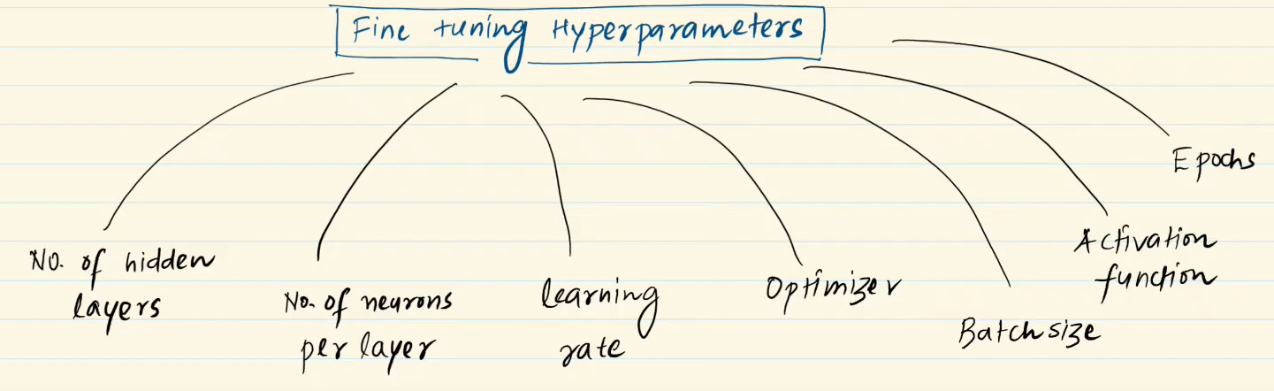

## No. of hidden layers

One Hidden layer with maximum nodes / multiple hidden layers with fewer nodes.

Best case is multiple layers because :

1. Lower layers identify primitive features .
2. Higher layers combine them then make shapes.

1. So if there is only one hidden layer there is no identification at all.
2. Just watch for overfitting if that occurs and stop increasing them .
3. Benefit is to reuse code for primitive layers and train higher one's for different purposes.

## 

## 2. No. of neurons per layer

Generally pyramid architecture formed , (64 , 32 , 16). Firstly more nodes are taken to lower layers to identify all the primitive features possible.

Can also take (32, 32 , 32). So take sufficient nodes because all features should be captured and max possible combinations would be there.

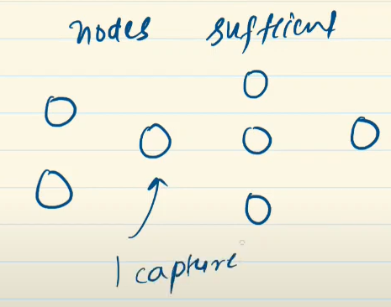

There cannot be like this because if primitive features are not captured then how can it make correct results?

## 3. Batch size

It is a hyperparameter , and can be smaller / larger .

Smaller (8 to 32) - can interpret results fastly . generalization better.

Larger (8192) - need to “Warming up the learning Rate” for this to get better results .

First use larger if not working use smaller.

## 4. Epochs

Use early stopping means stop when loss does not reduce.

# Problems to solve :

